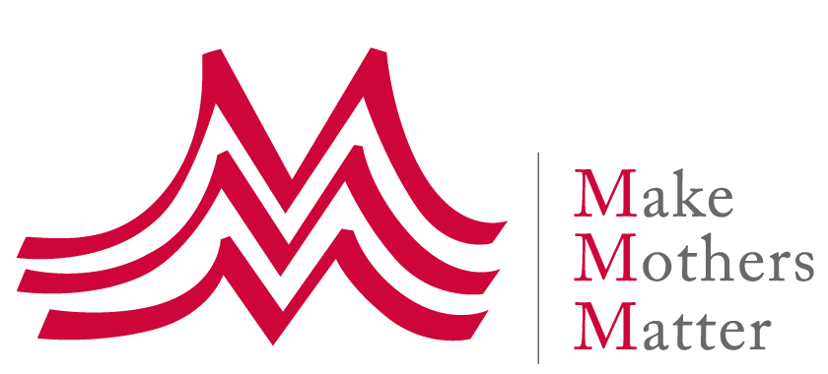

Press Release
12 November 2020

"No sustainable peace in Afghanistan without education for women & girls", says former UN Special Envoy Staffan de Mistura

#RaiseAPen Campaign kicks off

Global personalities have been raising their pens in support of MMM’s #RaiseAPen campaign, to amplify the voices of Afghan mothers calling for the continued right to education for their daughters.

Dr Habiba Sarabi, the first woman Governor of Bamyan Province and member of the Negotiating Delegation I.R of Afghanistan in the ongoing Doha intra Afghan peace talks, spoke to MMM about the importance of continued education for all: “If we educate a man we educate a person. If we educate a woman we educate a family and society.”

H.E Rangina Hamidi, Minister of Education, I.R of Afghanistan gave her assurance that no one will be left behind: “It is my responsibility to make sure that all the little girls in this country who have a dream of becoming educated don’t get their dreams snatched away from them”.

Much of Afghanistan’s progress over the past 18 years can be attributed to the power of the pen and the resilience of Afghan women themselves, who have fought to bring about meaningful change.

Staffan de Mistura, former UN Special Envoy to Afghanistan who is championing the #RaiseAPen campaign, told MMM: “This call comes at a critical moment for Afghanistan. There can be no sustainable peace in the country without education for all, but most importantly, education for women and girls who represent 51% of the population”.

Today, many of the 51% who have benefitted from years of peace and opportunity, are visible, active and impactful in diverse spheres of life. From politics to activism, entrepreneurship to industry, they are determined to realise their vision of an Afghanistan where every woman can live in peace and enjoy her rights.

But there is much that still needs to happen to allow more Afghan girls and women to participate in the development of their country.

“Girls’ education is not just a basic human right. It is also key to changing the mentality of society,” Dr Sima Samar, Afghan Woman’s and human rights activist told MMM.

MMM President Anne-Claire de Liedekerke summed up the need for the campaign: “No one wants to see a reversal of years of progress for women and girls in Afghanistan. This is why today, with Afghan mothers, and our civil society partners in Afghanistan, the Farkhunda Trust for Afghan Women’s Education and Mothers For Peace”, we #RaiseAPen to ensure a forward movement by raising global awareness for their call.”

International personalities who have given the campaign their support include:
- Rangina Hamidi, Minister of education, I.R of Afghanistan
- Rahela Sidiqi, Founder & Director of Farkhunda Trust for Afghan women’s education
- Stefania Giannini, UNESCO Assistant Director General of Education
- Najat Maalla M’jid, UN Special Representative on violence against children
- Dr. Koumbou Boly Barry, UN Special Rapporteur on the right to education
- Amb. Mohammad Wali Naeemi, Deputy Permanent Representative of I.R of Afghanistan to the UN
- Melanne Verveer, Executive Director Georgetown Institute for Women, Peace and Security
- Staffan de Mistura, former UN Special Envoy to Afghanistan
- Mary Kaldor, Professor of Global Governance and CEO of the Conflict Research Program, IDEAS, London School of Economics and Political Science
- Rima Salah, former Deputy Executive director of UNICEF & Chair of ECPC
- Habiba Sarabi, Member of the Peace Negotiating Delegation I.R of Afghanistan
- Roya Mahboob, Afghan entrepreneur and philanthropist
- Dr Sima Samar, Afghan Woman’s & Human Rights advocate

View the mobilisation video - share it if you have time using the #RaiseAPen hashtag

Join the high-level virtual panel discussion on Nov 25th to hear key decision makers discuss the way forward beyond ‘raising a pen’: Register here

For media inquiries please contact:
Shahnaz Pakravan, MMM Communications Manager
shahnaz@makemothersmatter.org

About Make Mother Matter – www.makemothersmatter.org

Make Mothers Matter (MMM) is an international NGO created in 1947 to raise the awareness of policy makers and public opinion on the contribution of mothers to social, cultural and economic development. MMM has no political or religious affiliations, and thus transparently voices the concerns of mothers at international level with permanent representatives at the United Nations (General Consultative Status), UNESCO and the European Union.

MMM federates a network of about 40 grassroots organisations working in about 30 countries across the world to support and empower mothers and their families, and to advance the human rights of women and children.

