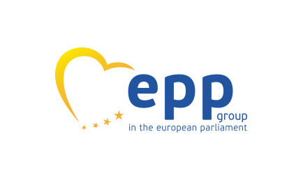

Care on the Move: The Forgotten Angle
The Gender Care Gap and Intra-EU mobility

Featuring Dr. Nina Miller, Glasgow University
In collaboration with Make Mothers Matter

Venue: The European Parliament
Date: Tuesday, February 28, 2023
Time: 12.30-14:30 CET
Room: SPINELLI 5 G305

Hosts MEPs Christine Schneider and Maria Noichl

EU citizenship and the free movement rules affect the reality of care in the context of intra-EU mobility with an impact on women’s ability to access free movement rights and protections. This event will shed light on the consequences faced by mobile EU citizen families, both those with caring responsibilities and those being cared for, including children.

Speakers will include:

Prof. Nicole Busby, University of Glasgow, Law School
Prof. Charlotte O’Brien, University of York, Law School
Dr. Adrienne Yong, City University of London, Law School
Prof. Anna Maria Konsta, Aristotle University of Thessaloniki, Faculty of Law
Dr Alice Welsh, York University, Law School
MEP Sirpa Pietikäinen, European Parliament
Ms Katarina Ivankovic-Knezevic (Director for Social Affairs and Inclusion DG EMPL, European Commission)
Ms Marion Finke (Member of Cabinet of Vice-President Dubravka Šuica, European Commission)
Ms Jolanta Reingarde, EIGE
MMM, EWL, COFACE, ECAS, Eurocities

Registrations under eudelegation@makemothersmatter.org

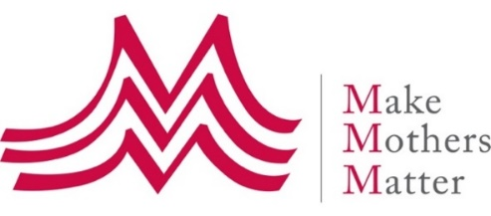
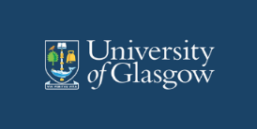

Also supported by 